**Take the Pulse**

**Introduction:**

***Take the Pulse*** *is an iOS mobile application designed for communities.*

*It addresses two aspects: real-time identification of the subjects of interest at community level and obtaining quick feedback on those subjects from community members.*

*The product tries to assure an equilibrium between two aspects -* ***user privacy*** *and* ***opinion's reliability*** *- but the main focus is on the first one.*

*That's why the target group is constitute of people eager to be in sync with the latest subjects and having an* open-mindedness above average, which are not easily offended by comments that may not correspond with their own opinion.

**Features:**

**Current version:**

In order to access the application, the user must create a username and password, BUT no other personal information is required, so that the user's activity **can't** be easily tracked.

In the first version no password reminder mechanism exists, this feature will be added in future versions.

The user is able to add posts related to different subjects, to see the posts added by other users, to rate them or add comments to them. He can make multiple comments to a post, but can only rate it once.

The user is able to easily find the most recent topics, the most voted or commented ones, and is able to search the subjects of interest.

A moderation mechanism will be implemented in the future version to assure that the fair play in changing ideas is assured. For the first version, the posts and comments can be deactivated at database level.

**Future version:**

The following features will be implemented:

* Password recovery mechanism based on responses to questions
* Allow the user to easily see all his posts
* All the user to receive notifications on the votes and ratings received by his posts
* Allow the users to report rude or inaccurate comments or posts
* Define a web page for administrator, allowing him to deactivate rude posts or comments
* Allow the administrator to create polls

**Usage:**

The user enters the authentication page and is able to login or register

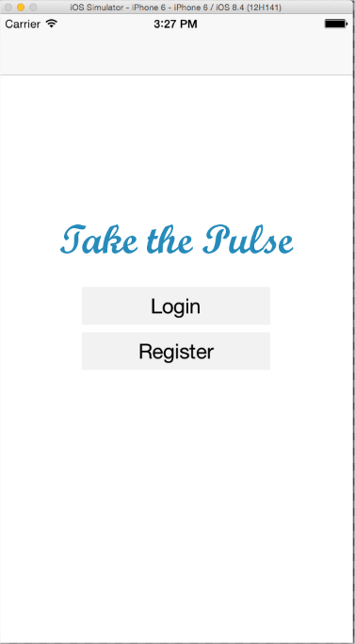

In the first version no password reminder mechanism exists, this feature will be added in future versions.

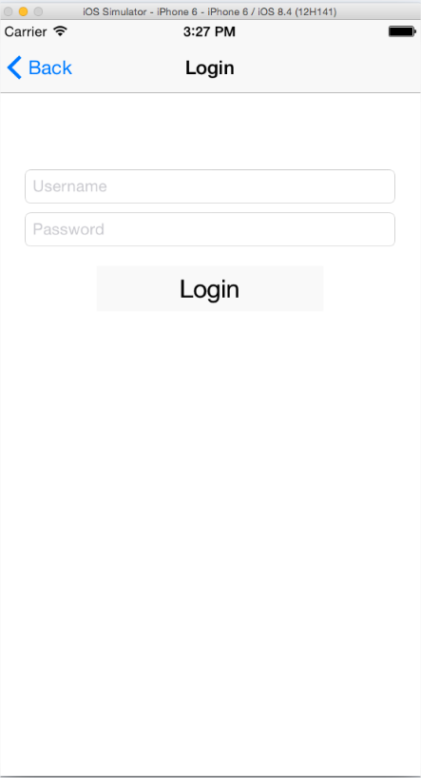 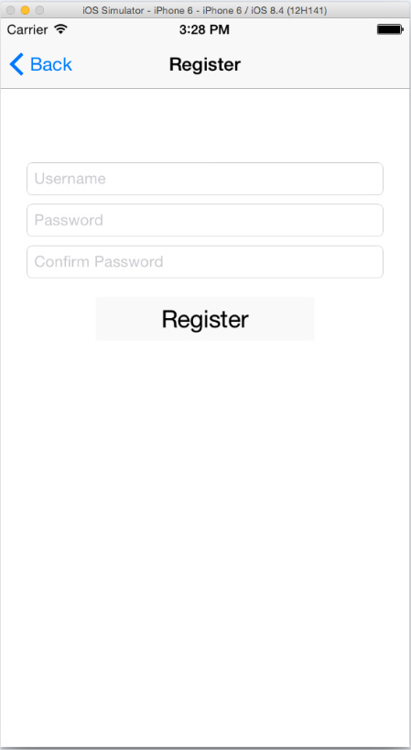

After Login, the user is redirected to the Main page.

There are three possibilities to see the posts: Top Rated (biggest rates), Popular (most voted) and Recent (the newest posts). There is, also, a search box, allowing to search on a certain topic.

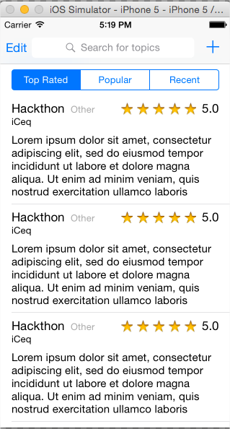

The user can use the (+) sign in this page to add a new post and he can choose the category.

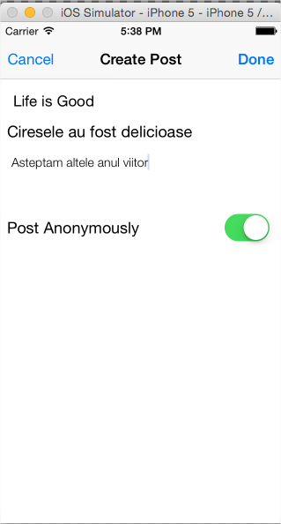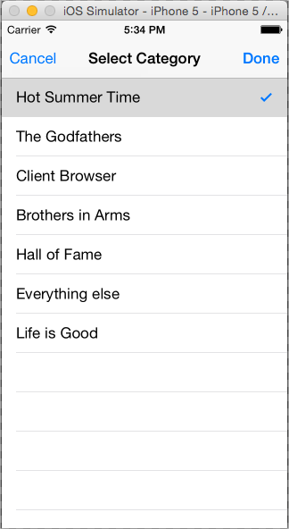

The users can , also, comment on a certain post and also can rate it.

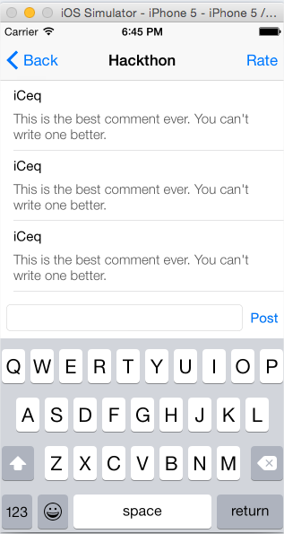 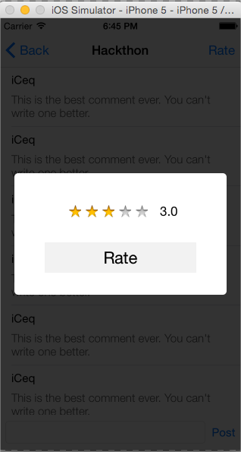

Database schema:

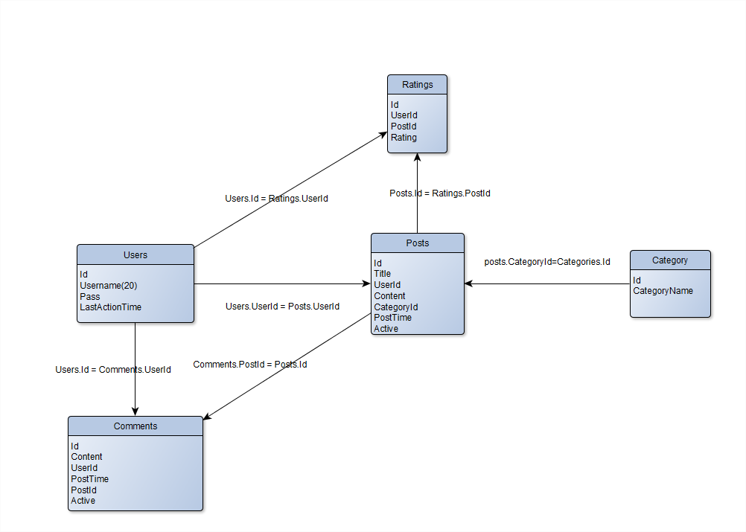

Basic application structure

